FITNORA
(A SMART WORKOUT AND FOOD TRACKING APP)
A PROJECT REPORT
Submitted By
SUBBU RAKESH S B
(Register No.: 23UCA503)
in partial fulfilment of the requirements
for the award of the degree of
BACHELOR OF COMPUTER APPLICATIONS
Under the Guidance of
Prof. E. ALEX PRABAHAR, M.Sc., M.Phil.,

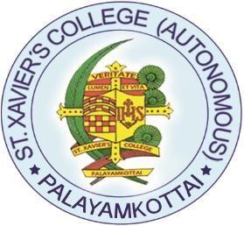

DEPARTMENT OF COMPUTER APPLICATIONS
ST. XAVIER’S COLLEGE (AUTONOMOUS)
(Recognized as ‘College with Potential for Excellence’ by UGC)
(Accredited by NAAC with “A++” Grade with a CGPA of 3.66 out of 4 in IV Cycle)
PALAYAMKOTTAI – 627002
MAY – 2026
DEPARTMENT OF COMPUTER APPLICATIONS
ST. XAVIER’S COLLEGE (AUTONOMOUS)
(Recognized as ‘College with Potential for Excellence’ by UGC)
(Accredited by NAAC with “A++” Grade with a CGPA of 3.66 out of 4 in IV Cycle)
PALAYAMKOTTAI – 627002

BONAFIDE CERTIFICATE
This is to certify that the project work entitled “FITNORA (A SMART WORKOUT AND FOOD TRACKING APP)” is the bona fide work of S. B. SUBBU RAKESH who carried out the project work under my supervision and submitted during the academic year 2025-26.
The Viva-voce held on ……………….

INTERNAL EXAMINER EXTERNAL EXAMINER

HEAD OF THE DEPARTMENT

